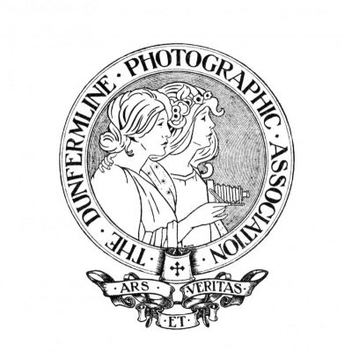

**Presidents Report for session 2024/2025**

**Meetings**

The year started off with our ongoing social evenings on the 1st Tuesday of each month to the Pitbauchlie House Hotel and trips out on the Summer Programme which had two trips out a month most months and were enjoyed by those that attended.

It’s been a busy year trying to heighten awareness of the club through advertising with Posters last summer around Dunfermline area, putting posts up on Facebook and word of mouth. Thanks go to those who assisted with that.

The number of members has now increased, and those that have joined us, have continued to attend.

We have continued to meet in the Del Farquharson Community Centre, enjoying a variety of talks, a practical evening to Culross (thanks to David Bolton) and a good variety of talks via Zoom.

I have visited Fife College and delivered a Presentation to the Photography/Media students and invited them to join us for an evening at the club. This week I am doing a Presentation to Dunfermline Rotary Club in the hope of securing some funding.

I have met with John Simpson from Visit Dunfermline and secured a tent at the Bruce Festival, which will allow us to display our images and freely advertise to an expected 20,000 visitors.

Looking forward we have new and exciting things planned for the coming year including collaboration with other photography clubs.

**Vice President and Syllabus**

Thanks go to David Bolton for his Vice President support, producing the Syllabus and arranging and booking interesting and varied speakers is much appreciated.

**Secretary and External Competition Secretary**

My thanks go to Alan Clark for producing the minutes of all our meetings and doing all the External Competition Secretarial work, including the SPF Digital Championship and SPF Print Championship and upcoming SPF Portfolio.

**Competition Secretary**

My thanks go to Ken Goodfellow for his work as Competition Secretary and also supporting me in moving into my role as President

We had a full complement of images entered into the monthly and annual competitions, and the change to the first monthly competition to DPI only, was a success making it less expensive and easy for members to take part.

My thanks go to all members who took part in all the competitions and congratulations to all winners in the monthly competitions and the annual. The awards will be issued at next week’s Annual Dinner and Awards evening.

**Treasurer**

My thanks go to Dennis Brookes who does an excellent job of keeping the books. For all his work each week, taking and recording the money and paying the bills. I also appreciate his help with the end of year Annual Dinner and awards finances.

**Website**

My thanks go to Ian Monk who has maintained the club website, adding images, and Blogs following our competitions and updating all the information.

**Social Secretary**

My thanks to Marjory MacIntosh who arranges all the refreshments, set up and clearing away, all year as well as all the arrangements and booking of the Annual Dinner and Raffles held throughout the year.

**Council Members**

Thanks go to Council Members (Alan Petrie, David Langskaill, Colin Joyce) who attend committee meetings and help with decision making.

**Summer and Winter Safaris**

Thank you to all members who formed teams to take part in the Safaris these would not be possible without your participation. Thanks go to Arthur Cook and Ken Goodfellow who put the work in to coming up with the safari route and making them excellent days out.

**Finally**

I would like to thank all committee members and members of the club for supporting me in my first year as President, for all your help and participation. Without your support and attendance this club would not be what it is. The club is growing in strength and numbers, and continues to be a great photography club to be a member of, both photographically and socially.

Gillian Temple DPAGB LRPS BPE2

President