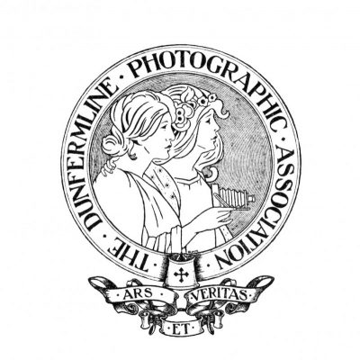
Presidents Report for session 2025/2026
Meetings
It’s been a busy year starting with the social evenings on the 1st Tuesday of each month in the Pitbauchlie House Hotel, plus trips out on the Summer Programme, although not attended by everyone there are a regular group of people who do attend both.
This year has been focused on the upcoming Centenary Event. The Event will be held in the Dell Farquharson Community Centre. We have the 3 rooms booked for the occasion. The main hall will be for the speakers and the then and now exhibition. The small room through the back will be for refreshments and catering and the 3rd room will be for further work from members on exhibit.
On the day we will have Libby Smith open the event with an introduction about our club and then Douglas Annan will do a talk about the history of photography showing some of his old cameras and work, and then we are lucky to have Doug Allan agree to come and do the afternoon talk about his wildlife career as a photographer and filmmaker.
There will also be an exhibition in Dunfermline Library of our more recent work from the end of May 2026 to June 2026.
Last year we had a tent and gazebo booked at the Bruce Festival which was a great success and our images were used on our website and, also for PR for the Bruce Festival for the upcoming event this year. We have secured the tent again this year.

We have continued to meet in the Del Farquharson Community Centre, enjoying a variety of talks, a practical evening photographing models and an abstract photography tutorial and practical. The zoom talks we had fitted in very well in January when the weather is less favourable. Zooms were also shared between ourselves and DCC and KPS.
We hosted the first Exchange Evening with KPS. The evening was a Macro tutorial then practical session for everyone including our guests who were able to participate. This went very well and was well received by this club and the Kirkcaldy members.
We held our summer and winter safaris as normal and will continue to hold these again this coming year.
The change to the first monthly competition to DPI only, has been a success making it less expensive and easy for members to take part.
My thanks go to all members who took part in all the competitions.
Recently we arranged a visit from Adrian and Jane Lines in collaboration between ourselves, KPS, St Andrews and Falkirk sharing the cost of accommodation and travel, making it much more affordable. This was also a success and enjoyed by everyone.
Looking forward we plan for more collaboration with other photography clubs.
Vice President and Syllabus
Thanks go to David Bolton for his Vice President support, producing the Syllabus and arranging and booking interesting and varied speakers.

Secretary and External Competition Secretary
My thanks go to Alan Clark for producing the minutes of all our meetings and doing all the External Competition Secretarial work, including the SPF Digital Championship and SPF Print Championship and upcoming SPF Portfolio.
Competition Secretary
My thanks go to Ken Goodfellow for his work as Competition Secretary. Collecting the prints and dropping off at judges etc.
Treasurer
My thanks go to Dennis Brookes who does an excellent job of keeping the books. For all his work each week, taking and recording the money and paying the bills. I also appreciate his help with the end of year Annual Dinner and awards finances.
Website
My thanks go to Ian Monk who has maintained the club website, adding images, and Blogs following our competitions and updating all the information.
Social Secretary
My thanks to Marjory MacIntosh who arranges all the refreshments, set up and clearing away, all year as well as all the arrangements and booking of the Annual Dinner and raffles held throughout the year. The raffles are a lot of work and it is appreciated. Thank you.
Council Members
Thanks go to Council Members (Alan Petrie, David Langskaill, Colin Joyce, Tina Boswell) who attend committee meetings and help with decision making.

Summer and Winter Safaris
Thank you to all members who formed teams to take part in the Safaris these would not be possible without your participation. Thanks go to Arthur Cook and Allan Petrie who put the work in to coming up with the safari route and making them excellent days out.
Special thanks
Goes to all who have taken part in taking photos to help create the then and now photos for our Centenary event. A special thanks to David Bolton who has also gone out and photographed extra images for our exhibition to make up the numbers. Thanks to Ian who has helped getting some old photos and doing the drone shot. Thanks to Marjory for her time spent with me at Dunfermline Library sorting and picking from hundreds of photos and a big thank you to Pete and Tina Boswell who have done most of the mounting and wording on the old photos, so thank you all its much appreciated.
Finally
I would like to thank all committee members and members of the club for all your help and participation. Without your support and attendance this club would not be what it is. The club is about to celebrate being 100 years old so lets keep it going for us and future generations for another 100 years!!!.
Gillian Temple DPAGB LRPS BPE2
President

